**JAVASCRIPT BASIC & DOM**

* What is JavaScript?

Ans. JavaScript is a versatile and widely used programming language for creating interactive and dynamic web applications. It is commonly used for client-side scripting in web development, allowing developers to add interactivity, manipulate the Document Object Model (DOM), and perform various tasks within web browsers.

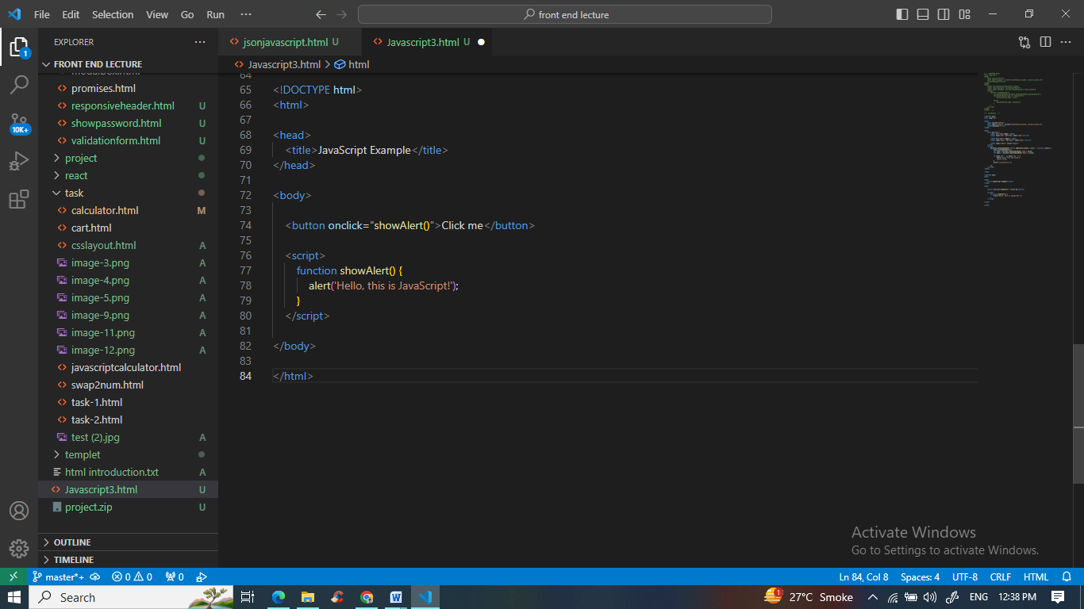

* What is the use of isNaN function?

Ans. The isNaN function in JavaScript is used to determine whether a value is "Not-a-Number" (NaN) or not. It returns true if the provided value is not a valid number and false if it is a valid number or can be coerced into one.

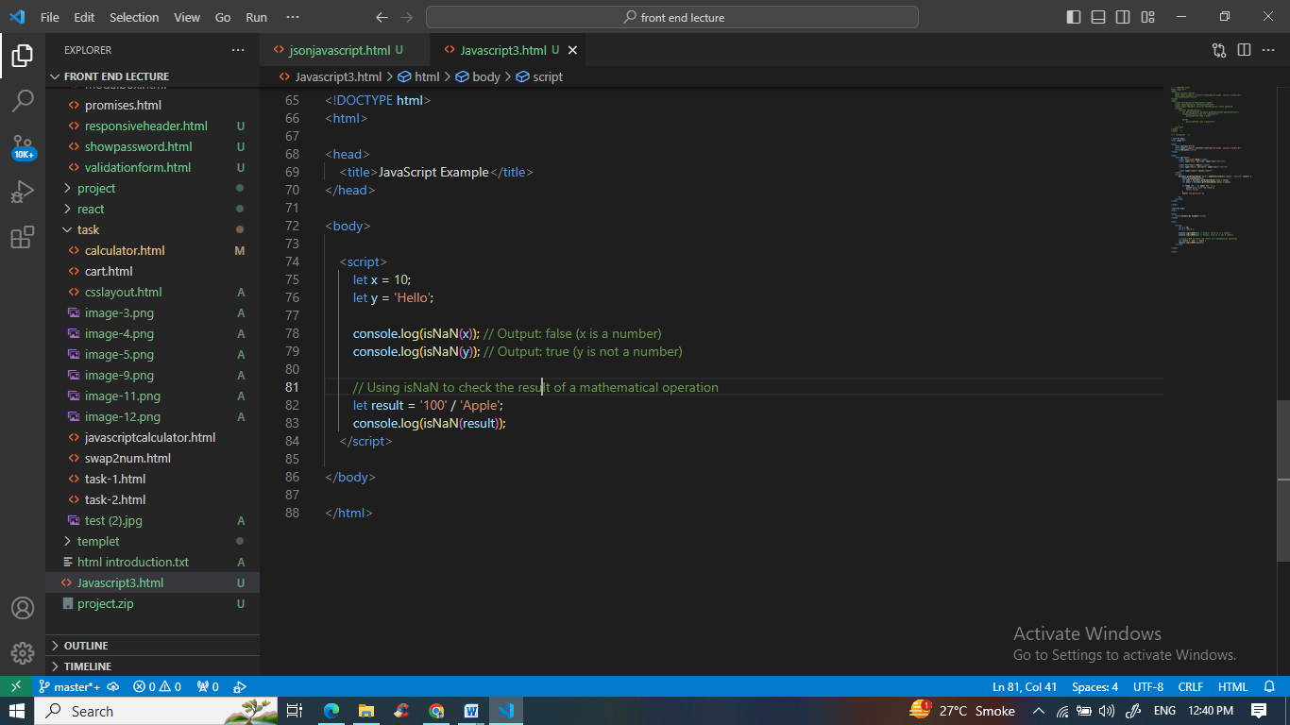

* What is negative Infinity?

Ans. Negative Infinity is a special value in JavaScript, representing a number that is smaller (more negative) than the smallest representable number. It is often the result of mathematical operations that approach negative infinity or underflow.

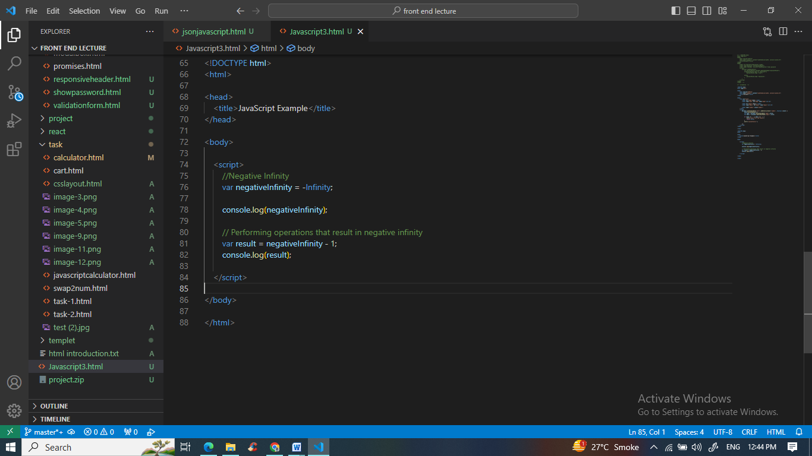

* Which company developed JavaScript?

Ans. JavaScript was developed by Netscape Communications Corporation. It was originally called "LiveScript" but was later renamed to "JavaScript."

* What are undeclared and undefined variables?

Ans. Undeclared variables are those that have been used in code but have not been declared using the var, let, or const keywords. They are typically global and can lead to unexpected behavior.

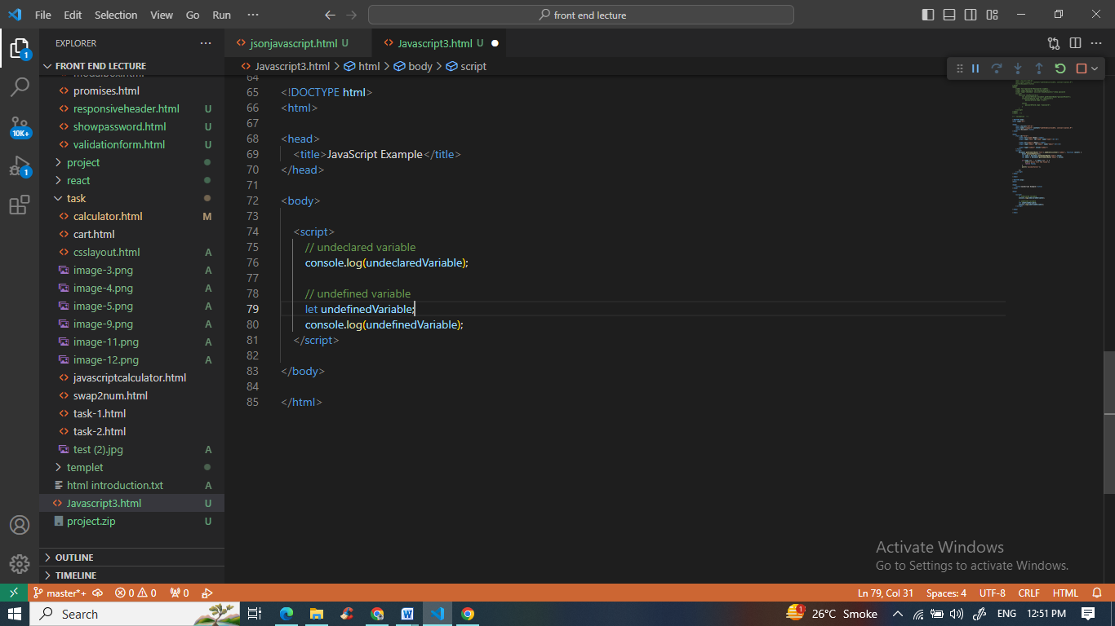

* Write the code for adding new elements dynamically?

Ans. Adding new elements dynamically in JavaScript can be done using the DOM (Document Object Model) manipulation

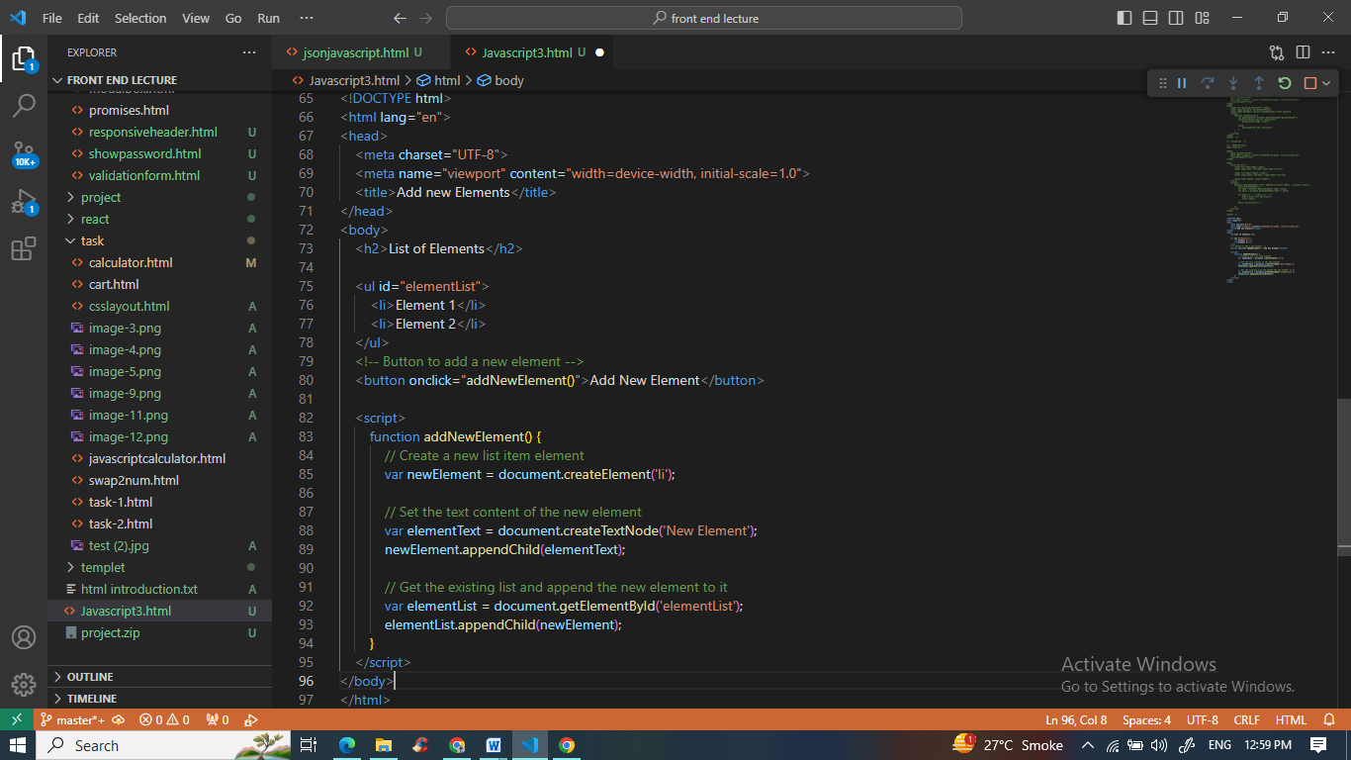

* What is the difference between ViewState and SessionState?

Ans. ViewState and SessionState are terms associated with ASP.NET and not JavaScript. ViewState is a client-side state management mechanism, and SessionState is server-side state management. They are used to store and retrieve data between HTTP requests in ASP.NET applications.

* What is === operator?

Ans. This operator is a strict equality operator check whether the two operands are equal, returning a Boolean result.

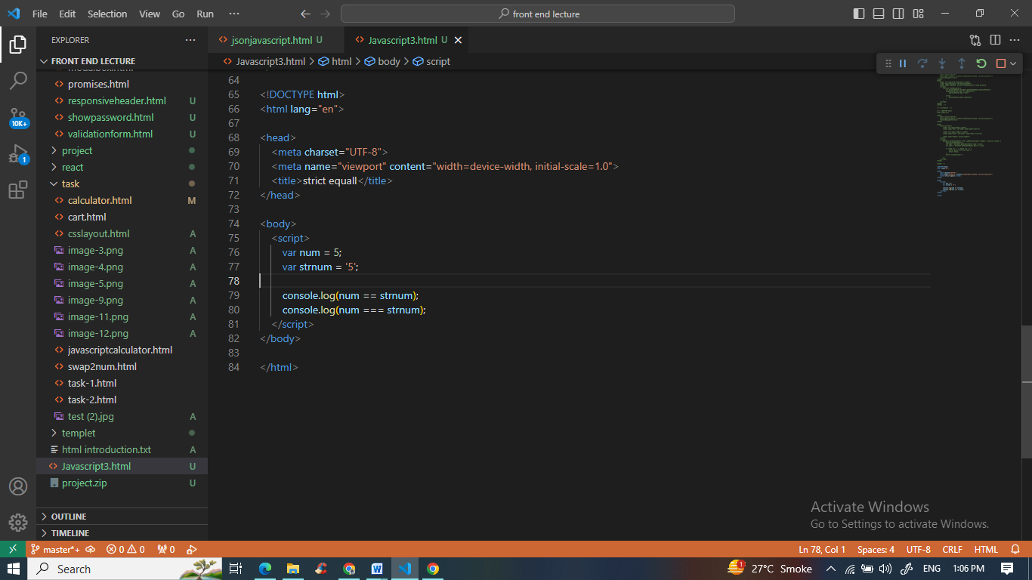

* How can the style/class of an element be changed?

Ans. To change the style name and class name of an element in javascript use this this method

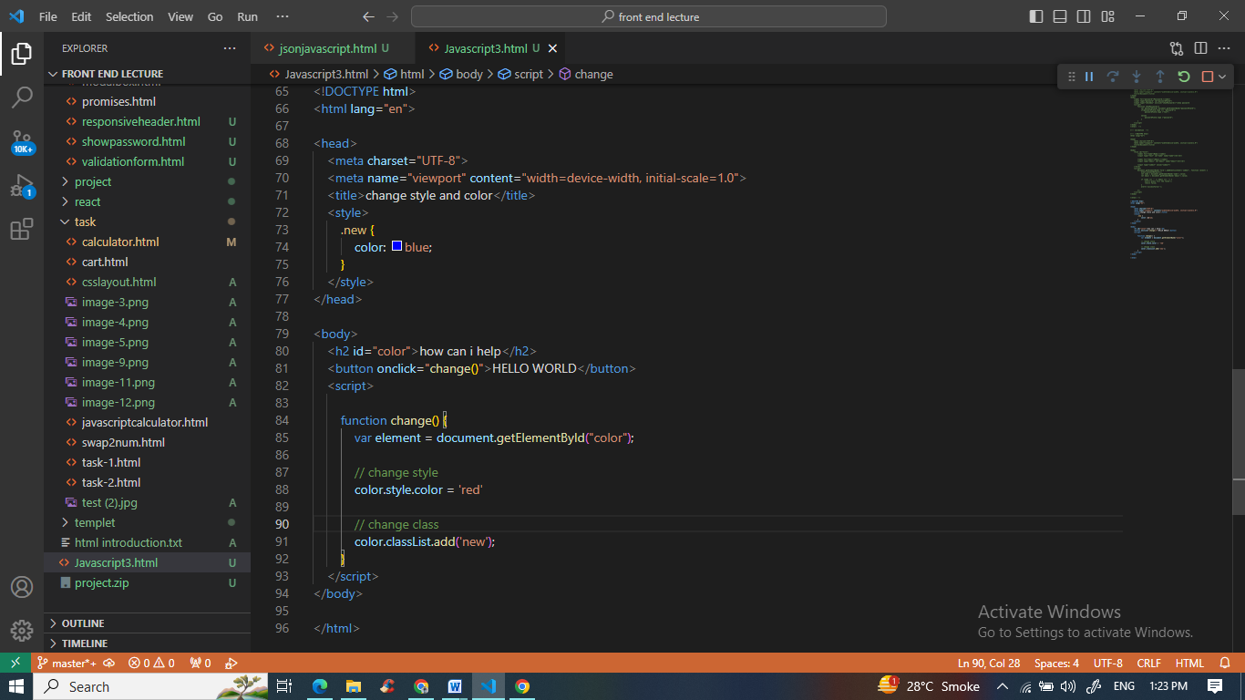

* How to read and write a file using JavaScript?

Ans. Reading and writing files using JavaScript is typically not possible in a web browser environment for security reasons. However, in server-side JavaScript (e.g., Node.js), you can use modules like fs for file I/O operations.

* What are all the looping structures in JavaScript?

Ans. The JavaScript loops are used to iterate the piece of code using for, while, do while or for-in loops. It makes the code compact. It is mostly used in array.

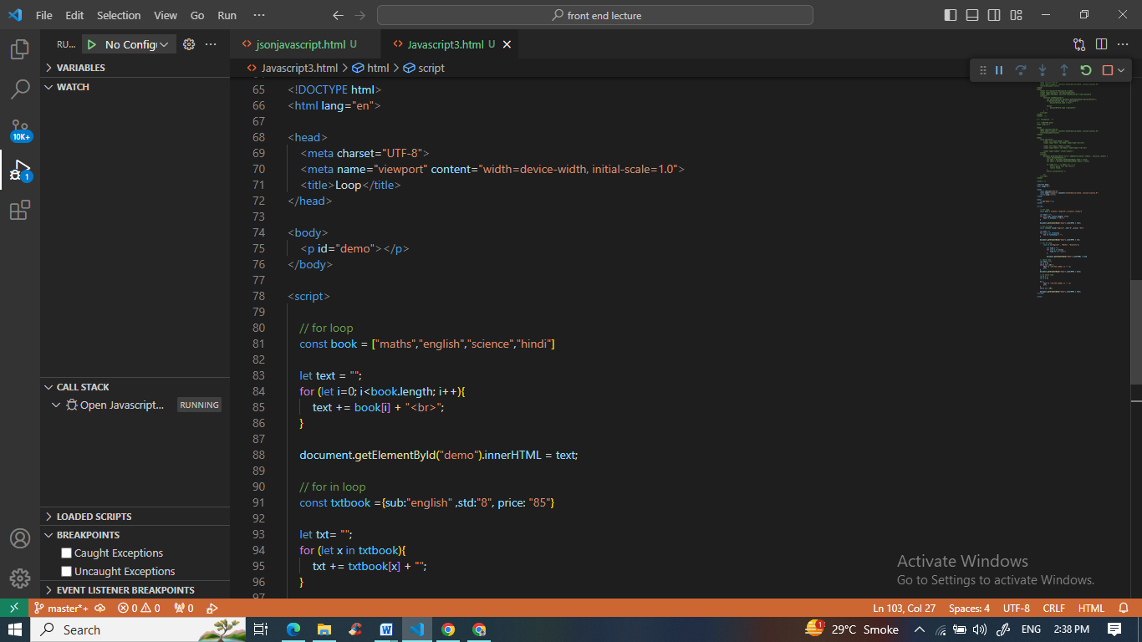

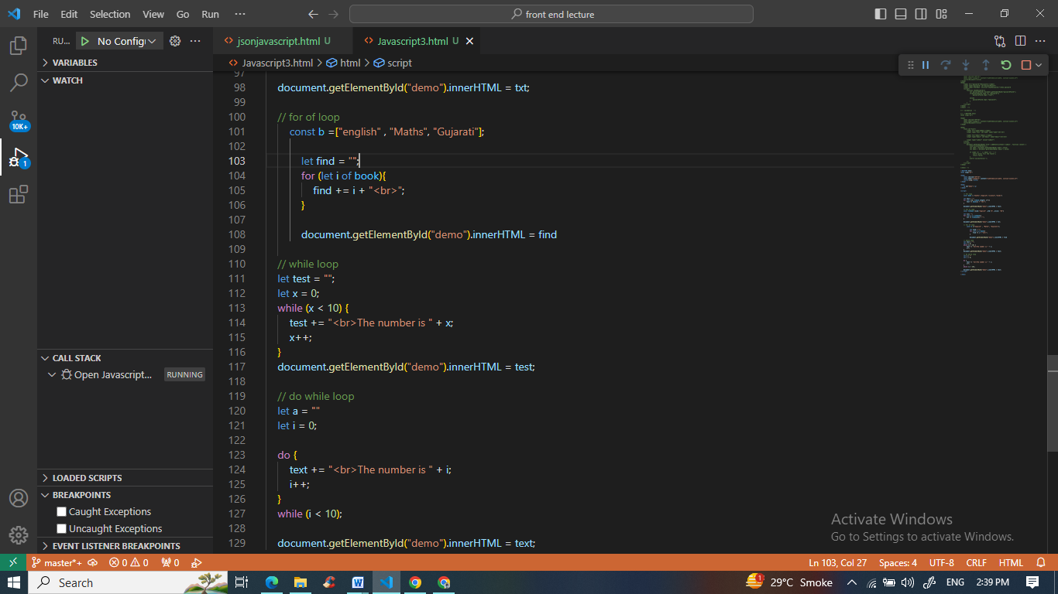

* How can you convert the string of any base to an integer in JavaScript?

Ans. To convert a string of any base to an integer in JavaScript, you can use the parseInt function with a specified radix (base). Example

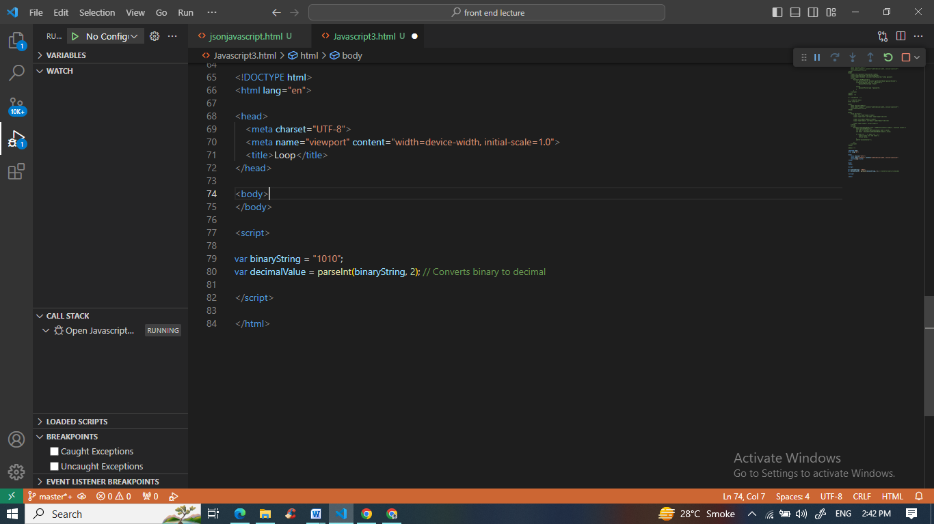

* What is the function of the delete operator?

Ans. The delete operator in JavaScript is used to delete a property from an object or an element from an array. For example:

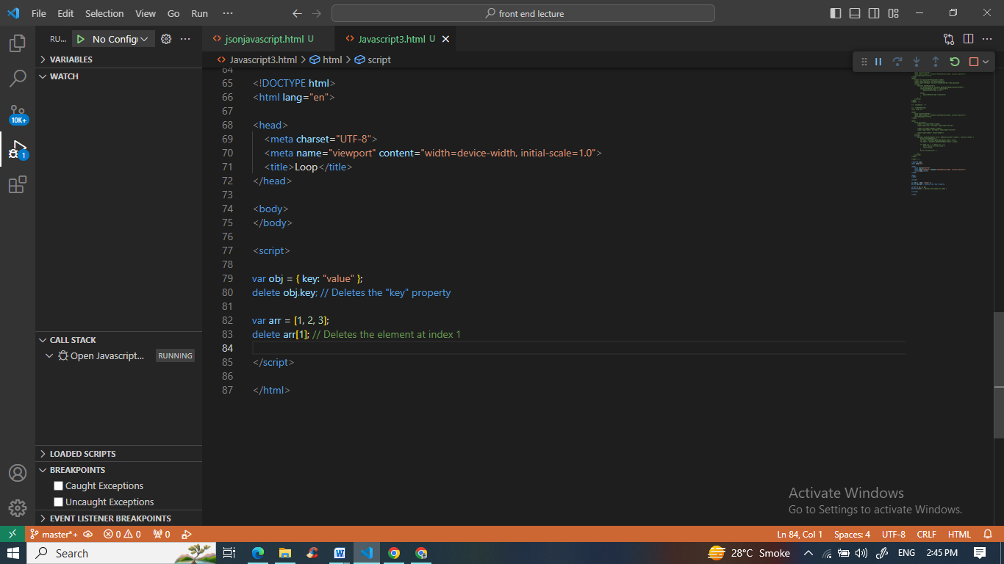

* What are all the types of Pop up boxes available in JavaScript?

Ans. In JavaScript, there are three types of pop-up boxes: alert, confirm, and prompt. These are used for displaying messages, confirming actions, and taking user input, respectively.

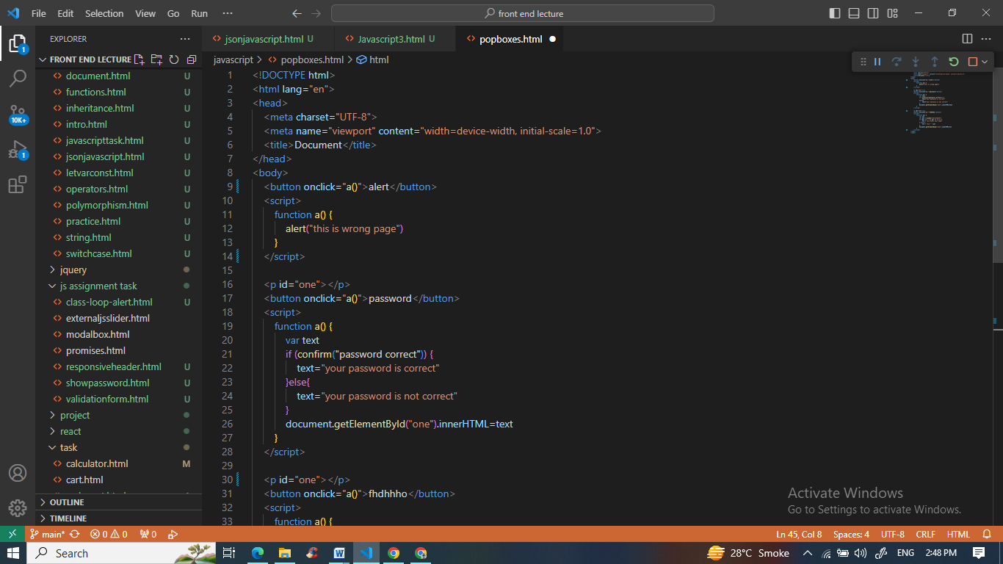

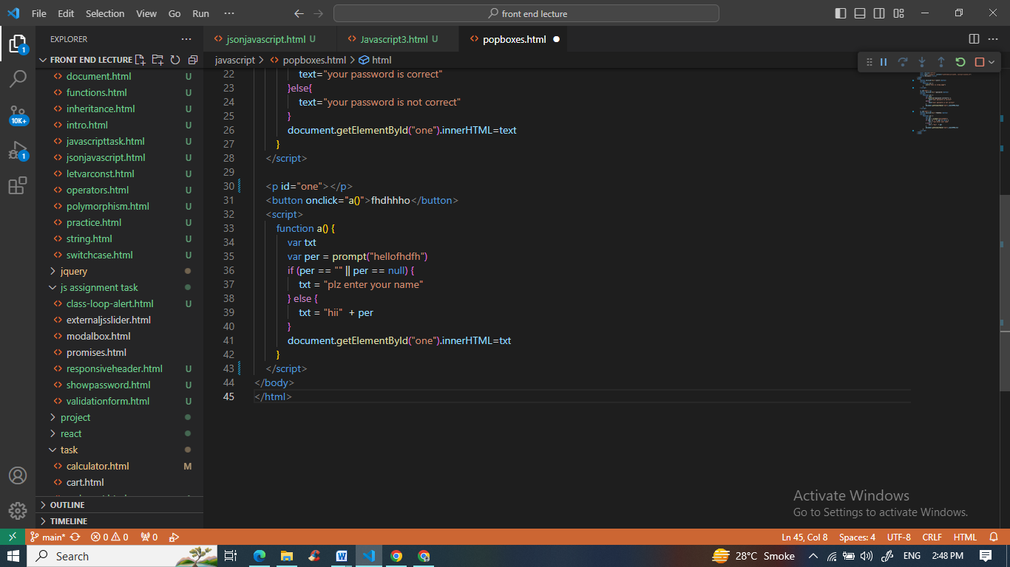

* What is the use of Void (0)?

Ans. void(0) is used to create a hyperlink with no action. It is often used in href attributes to prevent the page from navigating to a new URL when clicked.

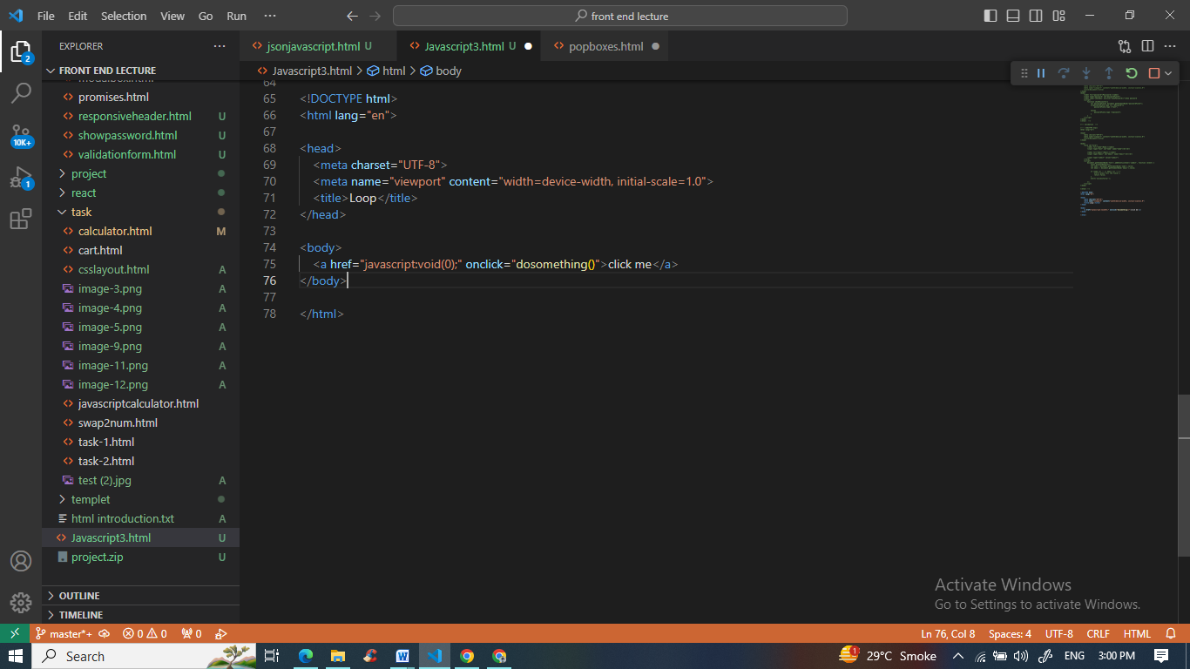

* How can a page be forced to load another page in JavaScript?

Ans. You can force a page to load another page in JavaScript by setting the window.location property to the new URL:

window.location.href = "newPage.html";

* What are the disadvantages of using innerHTML in JavaScript?

Ans. Disadvantages of using innerHTML in JavaScript include the risk of introducing cross-site scripting (XSS) vulnerabilities if you insert unescaped user-generated content directly into the DOM, and it can be slower for complex operations compared to other DOM manipulation methods.

* Create password field with show hide functionalities

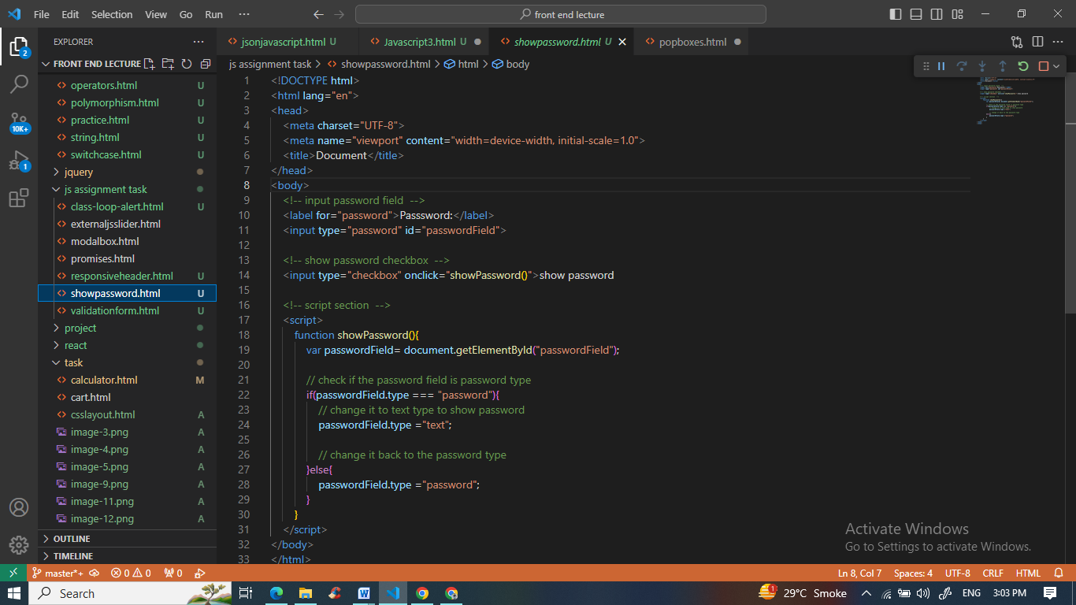

* Create basic math operation in JS

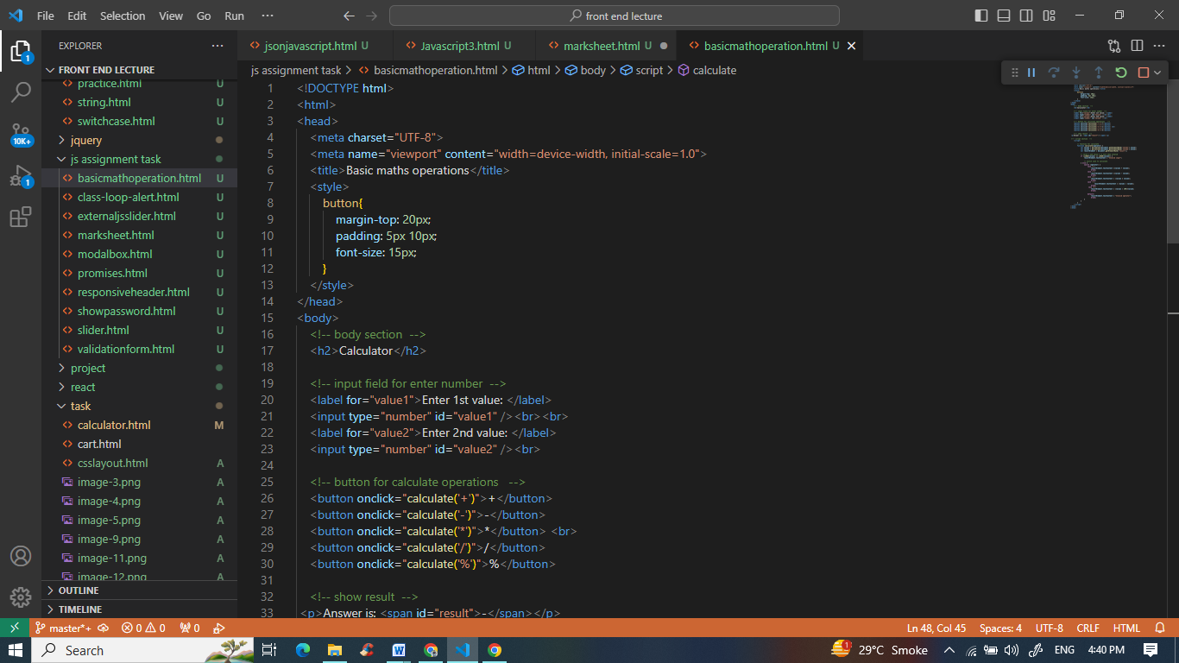

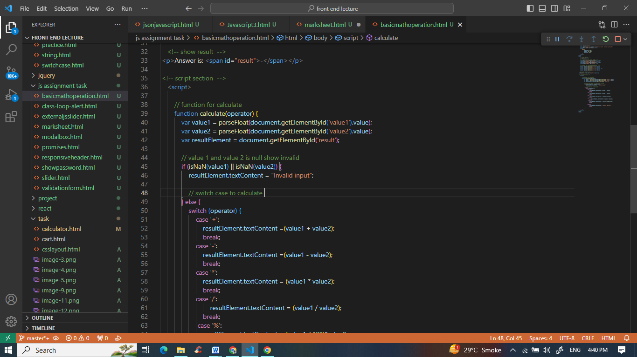

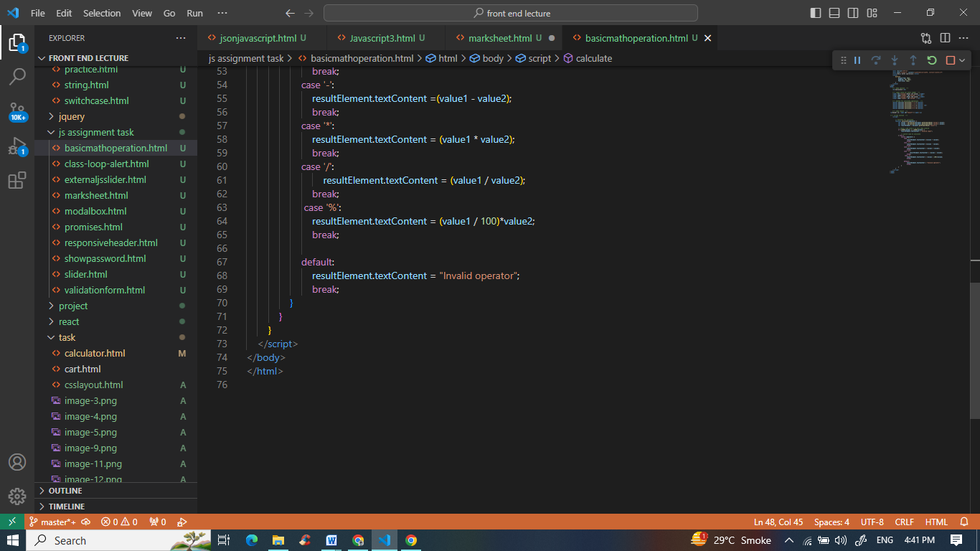

* Create result

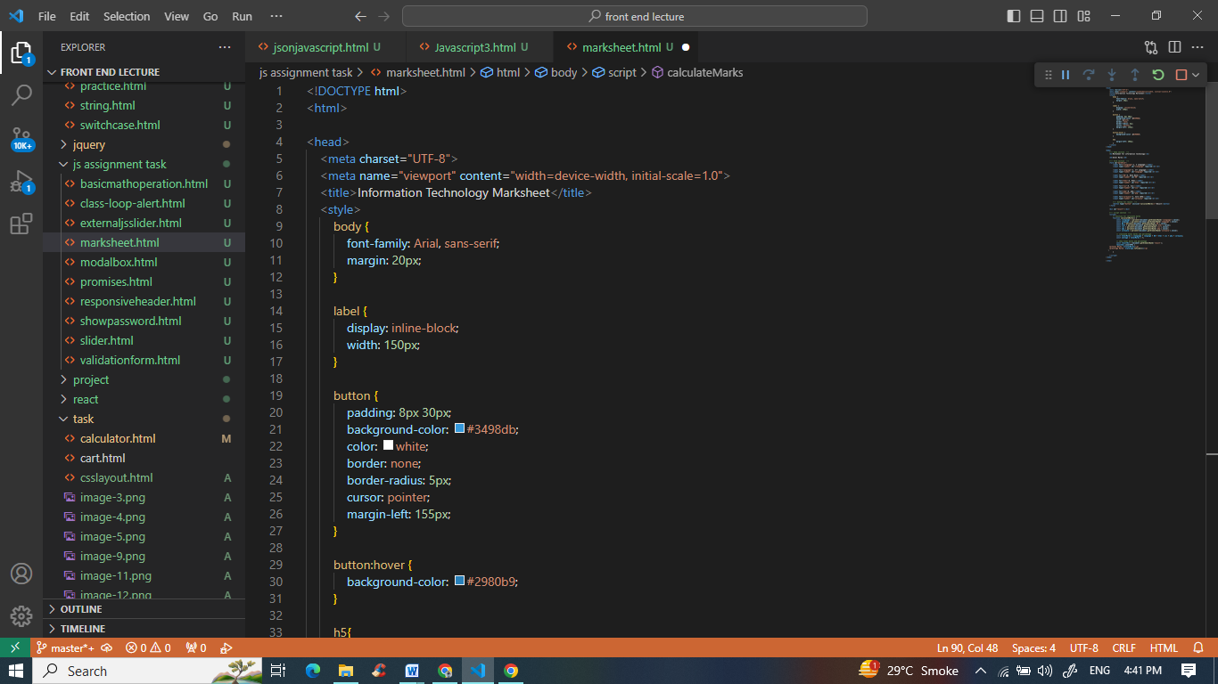

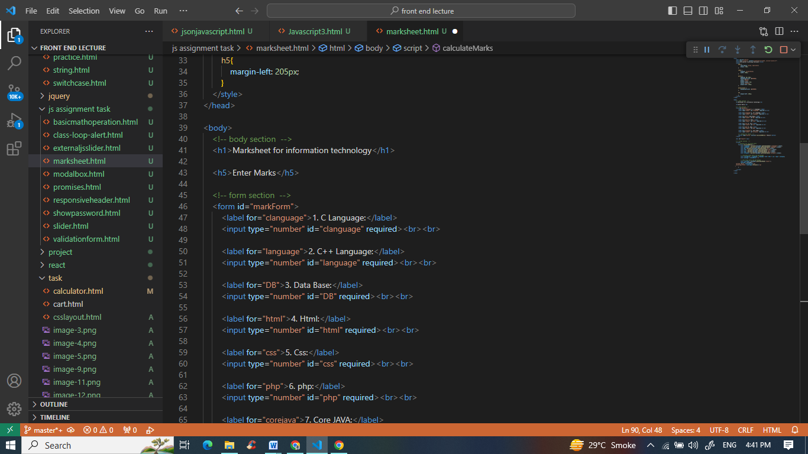

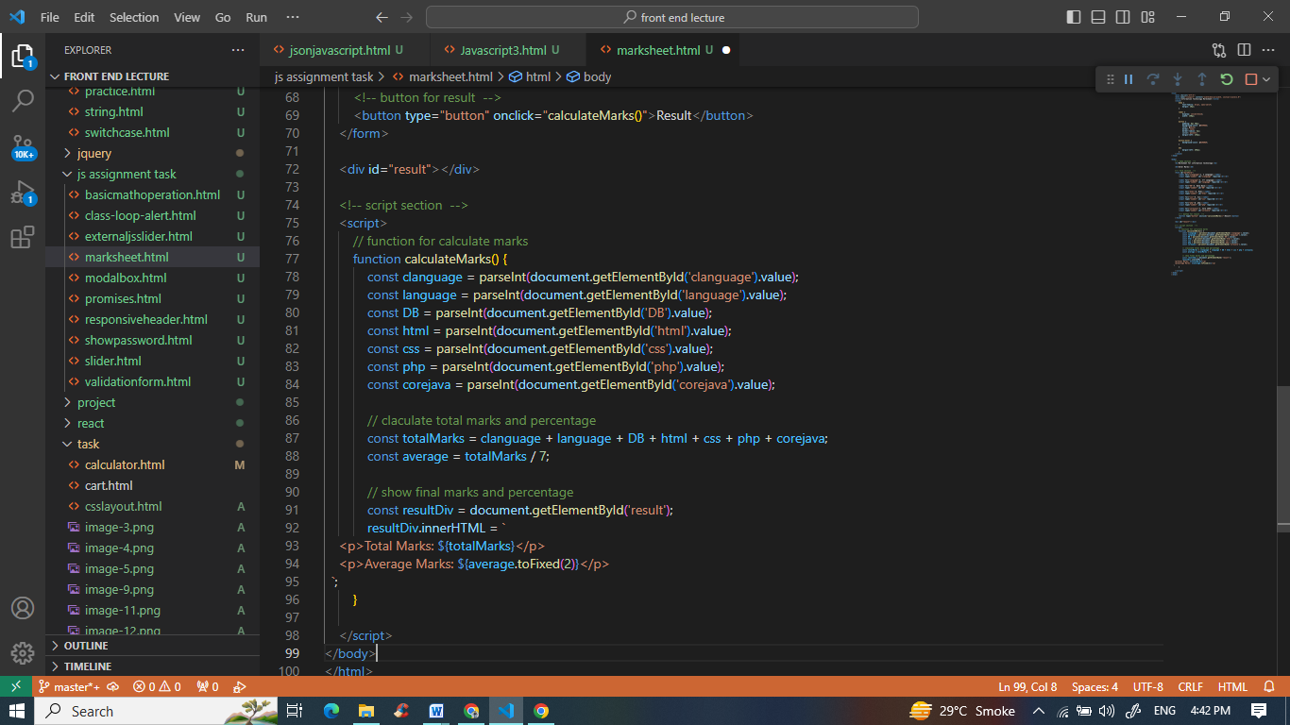

* Create a slider using JavaScript

